1)Trace the results of using the Apriori algorithm on the grocery store example with support threshold s=2

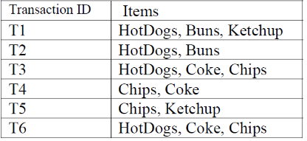

Results:

{hotdogs}, {buns}, {ketchup}, {chips}, {coke},

{hotdogs, buns}, {hotdogs, chips}, {coke, chips},

{hotdogs, coke, chips}.

2) Giving the following database with 5 transactions and a minimum support threshold of 60%

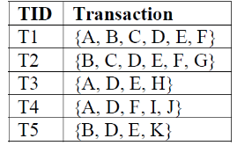

Results:

60%------>3times

{A}, {B}, {D}, {E}

{A, D}, {B, D}, {B, E}, {D, E}